**BUSINESS PROBLEM:**

We have two hotels namely City Hotel and Resort Hotel, Both are going under high cancellation rates and decline in revenue generated. Both hotels want an analyst to analyze the underlying issues that led to the decline in revenue and higher cancellation rates.

**SOLUTION:**

**Hypothesis and Assumptions made:**

* Rooms not allotted as per reserved category leads to cancellation.
* Higher Rates lead to higher cancellations.
* With the rise in technology, we assume more bookings from online Travel agents.

**Research Questions:**

* What are the Factors behind cancellation?
* What can be the effective measures to eliminate the issues?

**Insights from the analysis and the suggested solutions:**

* City Hotel has a higher cancellation rate:

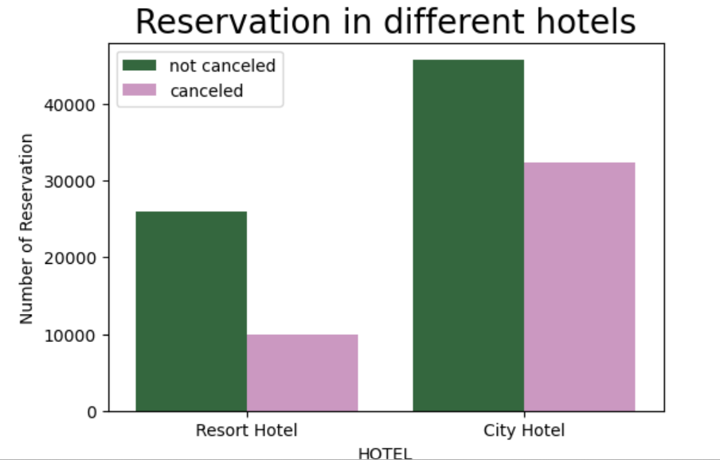

City Hotel has more bookings as well as higher cancellations too as compared to Resort Hotel.

To solve this issue City Hotel can provide some discounts to the customers.

* Higher Charges of City Hotel as compared to Resort Hotel:

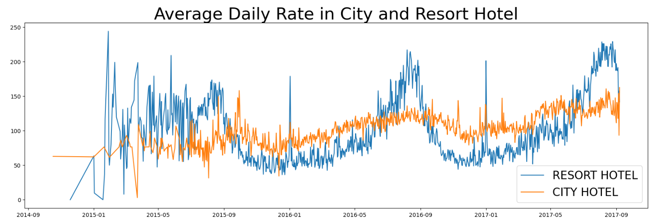

It can be observed that most of the time City Hotel has a higher Average Daily Rate (ADR) as compared to that of Resort Hotel. Spikes were observed for the higher ADR of Resort Hotel between June to August of each year but for the rest of the year City Hotel charges more.

**Higher ADR can be one of the reasons for higher cancellation rates in City Hotel.**

* Higher cancellations in Winter Season:

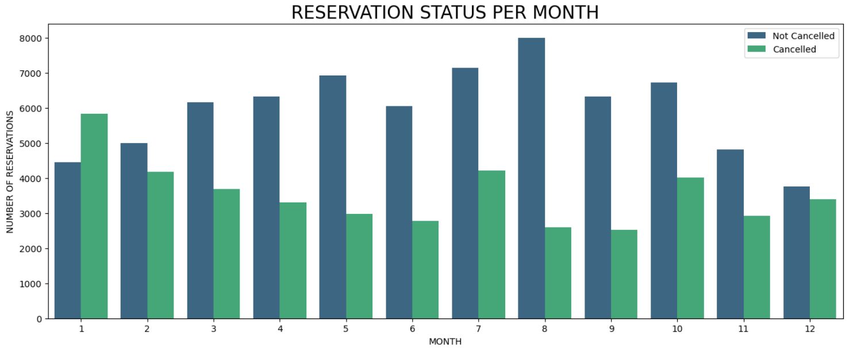

The month of November, December, January, and February which comprises the winter season witnesses a higher number of cancellations.

January has witnessed a higher number of cancellations than reservations.

It might be because of

* Poor quality of linens provided during winter.
* No availability of Room heaters during winter.
* Unavailability of Water geyser.
* Portugal facing the most number of cancellations.

Out of all the nations where Royal Hotel and City Hotel are operating, Portugal has near about 70% of cancellations.

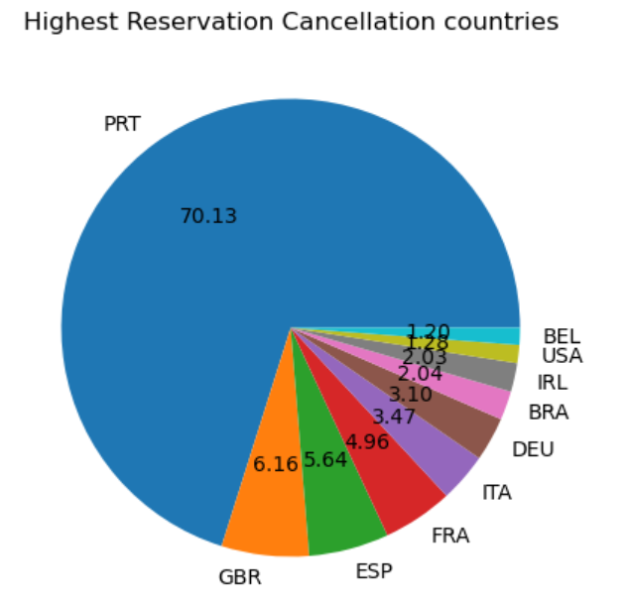

As a suggestion, both Hotels need to focus more on Portugal-located franchises.

They need to focus on the facilities being provided and address all the customer's complaints. That would be helpful in improving conditions and generating revenues.

* Online Travel Agents:

Online Travel agents have booked a higher number of ticket cancellations.

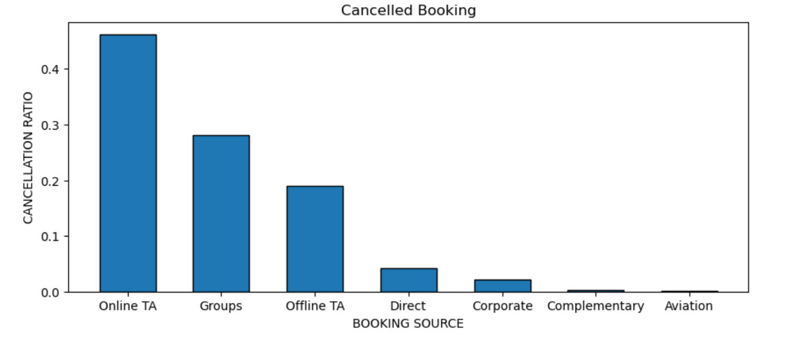

* Transient customers facing a higher number of cancellations.

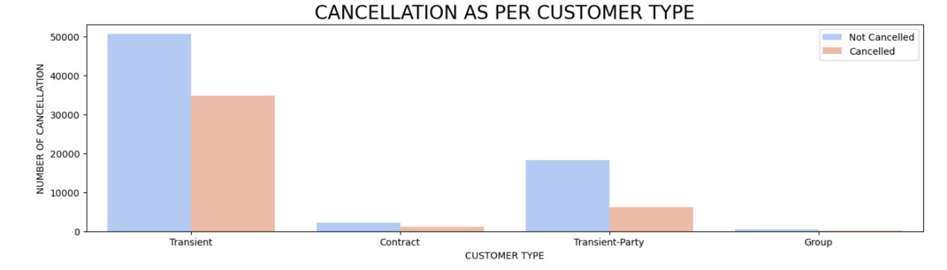Transient customers have a higher number of bookings but also faced a huge number of cancellations.